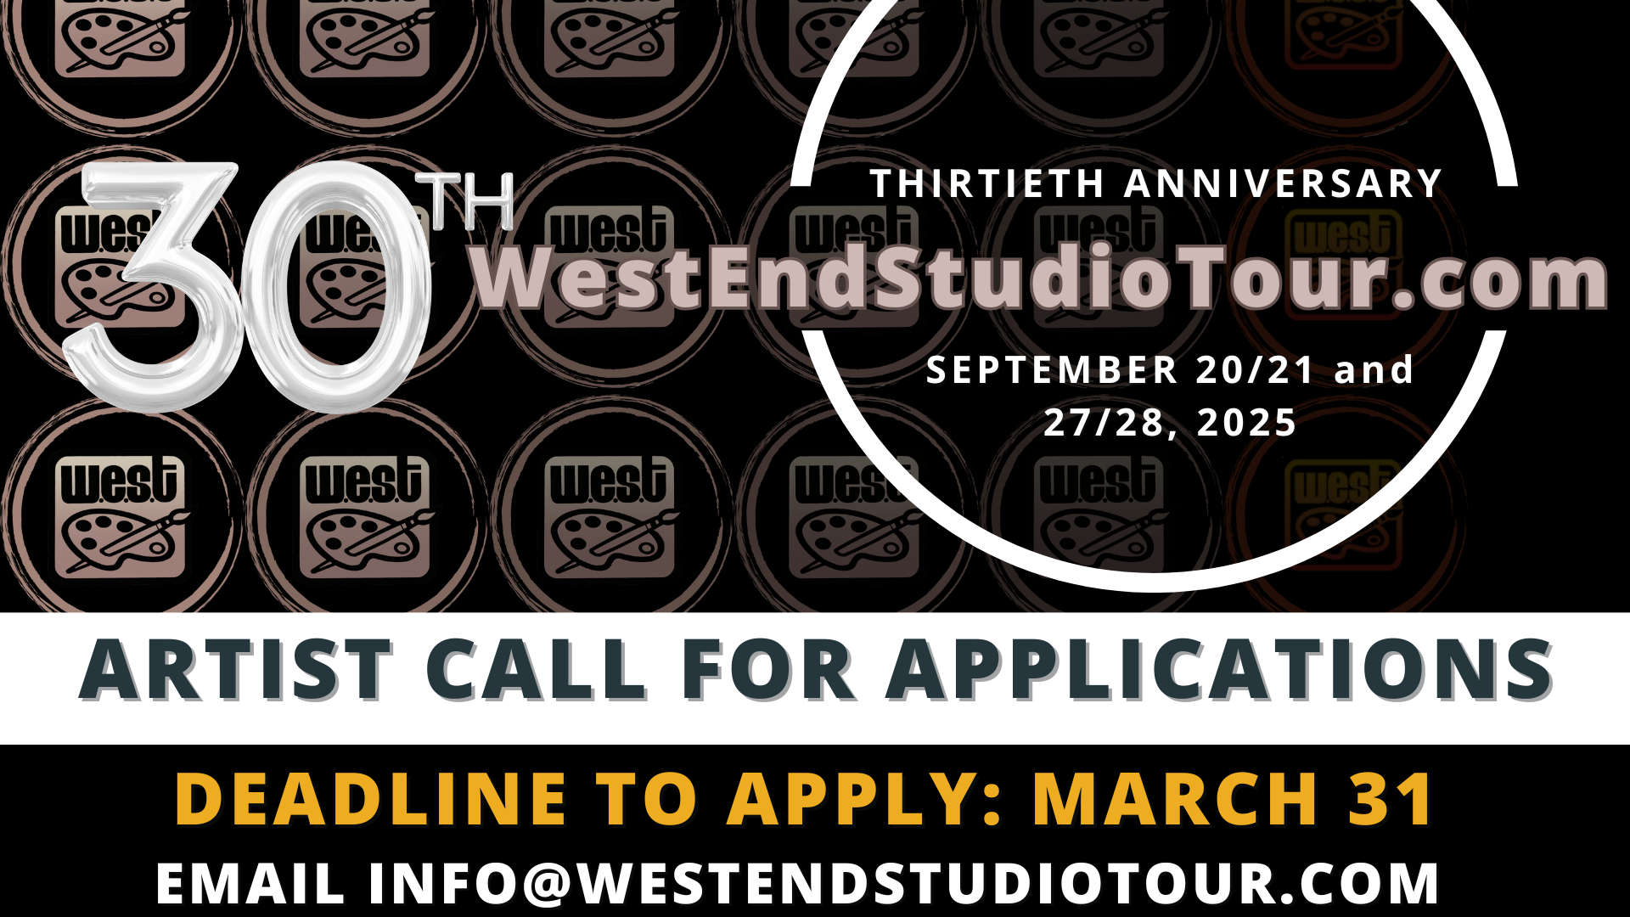

1. SEND US [info@westendstudiotour.com](mailto:info@westendstudiotour.com)

5 TO 10 MAX CLOSE-CROPPED IMAGES OF RECENT WORKS

2. SEND US A BRIEF ARTIST STATEMENT AND BIO

3. SEND US YOUR WEBSITE AND SOCIAL MEDIA HANDLE INFORMATION

4. INDICATE IF YOU ARE A GUEST ARTIST (*AND IF YOU HAVE OR NEED A PLACE TO EXHIBIT)

**OR**

IF YOU ARE ‘LOCAL’ AND LIVE WITHIN THE BOUNDARIES OF THE WEST TOUR PLEASE PROVIDE THE ADDRESS WHERE YOU ARE EXHIBITING

**WEST Boundaries**

North of Carling Avenue

South of the Ottawa River

East of Woodroffe Ave

West of Preston Street

*If accepted on the tour there will be a one-time administration fee of $40 and the cost for the tour this year is $150 per artist.

Everyone must participate in the first weekend of the tour September 20th/21st with the 2nd weekend September 27th/28th being optional